The University of North Carolina at Charlotte
Capital Projects
Facilities Management
9201 University City Blvd. Charlotte, N.C. 28223-0001
TEL: 704/687-0615

PROJECT: UNC Charlotte
Science Building
Advance Planning/Design Services
Code 46626 Item 301

Thank you for your interest in the subject project. This information is being provided to all firms which express an interest in the design of the project. Limit the size of your submittal document to no greater than 12½ inches in height and 9½ inches in width, maximum 50 pages, 25 pages when printing double sided – including standard forms, cover letters, and University issued Submittal Cover Sheets, but excluding the cover, tabs, separators, clear covers, blank pages, or cardstock backs. Actual page
counts will be derived from the electronic pdf submittal. Do not include covers, blank pages, tabs, separators, etc. in your electronic submittal. Submittals are due in my office by 2:00 p.m. Tuesday, May 24, 2016.

Do not transmit any submittal information via email.

Submittals must include the cover sheet, Sections I and II of the Standard Form 330, the Designer’s Supplemental Information Form, along with any additional information considered appropriate. Please deliver five copies of the submittal, along with one electronic copy in pdf format (CD, DVD, USB drive, etc. attached to a printed submittal) to my office at the address noted above. Each hard copy should be bound together as a document and the digital submission should be assembled into a single file.

All submittals will be reviewed by the University Designer Evaluation Committee. The preliminary evaluation process will be completed in early June and firms selected for interviews will be notified at that time. Interviews are scheduled to be held at the end of June.

There will be a mandatory pre-submittal conference for any interested parties held at
2:00 p.m. on Wednesday, May 11, 2016, in Room 222 Room 155, College of Health & Human Services (CHHS) Building (#63 on the campus map – http://facilities.uncc.edu/maps).
A non-mandatory walk to the site will take place immediately following the meeting. Visitor parking is available in Union Deck and Cone Decks 1& 2.

Please deliver all submittals to me at the address written above. Any questions about the project should be directed to the Project Manager, Donia Schauble at dschauble@uncc.edu.

Sincerely, Joyce Clay

The University of North Carolina at Charlotte
Science Building
Advance Planning/Design Services
Code 46626 Item 301

I. PROJECT DESCRIPTION: A. Project Overview
The new Science Building will support the University’s mission and goals by providing STEM interdisciplinary instructional and research space for UNC Charlotte’s growing student population and research activities.

The new facility will integrate undergraduate instructional laboratories, research laboratories, faculty and administrative offices, graduate student work space and collaboration space into a unified center for learning and research.

B. Project Goals

Academically, the building will foster and support:

− Undergraduate Science Education
− Science Education
− Faculty Research
− Student Research
− Interaction among Faculty and Students
− Showcasing Science, Disciplines, and Activities

The design of the new building will promote:

− Enhancement of the Campus
The new science building will be a significant asset to the campus and reinforce the aesthetic quality of the environment.

− Effective Use of Resources
The design of the new building will make the best use of the University’s financial, operational, real estate and spatial resources.

− Adaptability and Flexibility
The building must be designed to allow reconfiguration over time to meet the changing needs of instructional and research programs.

− Green Building Certification to a nationally recognized standard.

C. Program Needs

Program needs will be identified and developed in collaboration with representatives from the academic colleges and departments and the university administration. The

building will include specialized and general teaching, lecture, research space and support spaces for faculty and students. Academic and administrative office and office support space will be included in the building.

Program elements will include:
• Classrooms and laboratories for undergraduate instruction
• Research laboratories
• Core Research facilities
• Faculty and Administrative office space
• Interaction and study spaces for students
• Meeting and Conference rooms
• Building support space (utility, circulation, etc.)
• Regional Utility Plant

Additional program elements may be identified during the programming phase of the project.

D. Project Site

The site for the Science Building is located at the intersection of Craver Road and Mary Alexander Road. The proposed limits of the site are indicated on the attached Exhibits A & B. The existing Facilities Operations and Parking Services building, Receiving and Stores, and Steam Plant structures will all be demolished as part of the Science Building project. The replacement facilities will be separate projects and are planned to be completed and occupied prior to construction start of the Science Building project.

The project will include a Regional Utility Plant that will serve the new Science Building and hot water capacity to serve seven (7) other buildings on campus along with associated infrastructure.

The development of the site and placement of the building will respond to the 2010
Master Plan and will enhance the campus environment. Pedestrian access and relationships with existing and future buildings will inform the development of the site and the building design. Site development for the Science Building project will also have to address on site management of storm water.

E. Design Criteria and Guidelines

This project will be designed and constructed in accordance with provisions of SL
2007-546.

The design will be consistent with the Guiding Principles of the Campus Master Plan and the University’s Design Manual.

The 2010 Campus Master Plan can be viewed at http://masterplan.uncc.edu.
The University’s Design & Construction Manual can be viewed at
http://facilities.uncc.edu/DCManual

The design of the building will include:
• Exterior design consistent with established architectural style of campus, UNC Charlotte 2010 Campus Master Plan, and UNC Charlotte Design & Construction Manual.
• Simplicity of design with an emphasis on economical construction and maintainability.
• Effective and efficient HVAC, electrical, and communication systems.

EXPECTATIONS OF THE DESIGNER:

The Design Team must include professionals who demonstrate high standards of accomplishment and knowledge in the following areas:
• Experience programming, planning and designing academic science facilities for higher education.
• Experience and certification in green building standards.
• Experience designing instructional and research lab facilities for higher education.
• Knowledge and understanding of current and emerging directions in interdisciplinary, academic science teaching and research in higher education.
• Experience designing Regional Utility Plants.
• Experience with master planning / sector studies.
• Demonstrated ability to provide cost-effective design.
• Demonstrated ability to coordinate projects that involve multiple constituents.
• Demonstrated ability to understand campus needs and appropriate program and building adjacencies.
• Ability to successfully design utility infrastructure in an existing system.
- Successful experience in providing cost effective information technology, mechanical, electrical, and plumbing systems for projects of this scope.
• Programming, designing and administering construction for major projects within budget and in a timely manner – a proven track record.
• Experience with the Construction Manager at Risk construction delivery method and enhanced building commissioning;
• Familiarity with incorporating SL 2007-546.
• Experience with North Carolina State Construction Office and Department of
Insurance requirements and procedures;
• Experience using Building Information Modeling from design through construction.
• The proposed project design team members must demonstrate all above listed experience on their individual resumes. Sample projects must be recent and the proposed design team members must have performed key roles in the design of the sample projects.

Throughout Advance Planning the Designer will present sketches to the University to illustrate multiple options showing how the building and the project site will be developed.

Throughout Advance Planning the Designer will provide three-dimensional perspective

views of the exterior building utilizing CAD/BIM software as the design evolves. The Designer must be willing to conform to the established palette of building materials and site furnishings for new university facilities at UNC Charlotte.

III. SCOPE OF WORK:

The Designer will work with representatives from the academic departments, Facility Planning, Space Management and Capital Design to develop the preliminary planning documents including a building program, site development options, and project costs for the new Science Building.

Meetings with end users and facilities management personnel will be necessary to define project needs, functions, adjacencies, floor plans and equipment requirements.

Presentations to committees and university leadership to present options, solicit input and present recommendations will be required.

The Advance Planning Phase deliverables shall include:
• A narrative description of the project goals.
• A detailed square footage breakdown of all required spaces for the Science Building and the Regional Utility Plant. This description shall be in both narrative and spreadsheet format and identify all spaces required for useable
space, and all necessary support space such as mechanical equipment, circulation, etc.
• Functional and adjacency diagrams shall be developed showing the relationship of building spaces. This shall be based on the analysis outlined above. Final adjacencies will include both function and economy.
• Descriptive narratives for all building systems including mechanical, electrical, plumbing and telecommunications, as established by the Consultants.
• Descriptive narratives for support spaces including service areas, mechanical, electrical and plumbing spaces, maintenance facilities, and other required spaces not listed above.
• Building demand for basic utility services to the building including water, sewer, power, gas, telecommunications and HVAC systems. The Program shall include utility and other service extensions, such as lighting, and sidewalks, to connect with the existing UNC Charlotte system.
• Concept diagrams and descriptive narratives for student, faculty, visitor and staff entrances and all required life safety provisions such as, but not limited to, rated corridors and exits.
• Concept diagrams and descriptive narratives of vehicular access to accommodate adjacent building deliveries, emergency access, maintenance and waste disposal services.
• Detailed Cost estimate with projections on escalation for the Science Building,
the Regional Utility Plant, and associated site development for site work including but not limited to drainage, roads, parking, walks, irrigation, signage, utilities, etc.

• Conceptual site development plans showing the placement of the building on the site and development of outdoor plazas, walks, service areas.
• An evaluation of site requirements for parking, lighting, security and required connections to both current and future building needs.

The Designer shall schedule meetings with designated University representatives to review required data collection, technical, maintenance, budget and schedule requirements.

The Designer shall develop a final Program Documents that meet the University’s needs and are suitable for submission to State Construction Office for approval (refer to State Construction Manual, Section 305).

Upon successful completion of the Advance Planning phase, University staff may solicit complete and comprehensive design services for the project from the designer and their subconsultants. Refer to State Construction Manual, Chapter 300, Project Design Phases.

DESIGNER SELECTION CRITERIA

As detailed in the North Carolina Administrative Code (01 NCAC 30D.0303), the University’s Design Selection Committee will use the following in evaluating qualifications:

(1) Specialized or appropriate expertise in the programming, design and construction administration of science buildings for higher education.
(2) Past performance on similar projects.
(3) Adequate staff for the proposed project design team. (4) Current workload and State projects awarded.
(5) Proposed design approach for the project.
(6) Recent experience with project costs and schedules. (7) Construction administration capabilities.
(8) Proximity to and familiarity with the area where project is located.
(9) Record of successfully completed projects without major legal or technical problems.
(10) Other factors that may be appropriate for the project.

Note:
The current workload and past performance of sub-consultants on the designer’s team will also be considered when evaluating qualifications.
For all relevant project examples submitted, provide a matrix indicating which design team members worked on the project(s).

SUBMITTAL REQUIREMENTS
• Provide a brief overview of the teams’ understanding of the project.
• Provide the team members’ accomplishments and responsibilities on similar projects with a specific focus on team’s experience with interdisciplinary science projects and knowledge of current trends in higher education science buildings.
• Provide a description of the team’s approach to delivering the project including team members’ responsibilities.
• For all relevant project examples submitted, provide a matrix indicating which design team members worked on the project(s).
• Five (5) bound booklets no more than 50 pages (25 if printing double sided) containing design consultants’ team with resumes and related work experience. Page limit shall be inclusive of Standard Form 330 Parts I & II.
• Submit booklet in digital format on one (1) DVD, CD, or USB drive in pdf format.
• Provide Information in the following Order:
A. UNC Charlotte Required Submittal Cover Sheet
B. Designer’s Supplemental Information Form
C. Cover Letter (Optional)
D. SF 330 Parts I & II (List square foot costs for all projects shown on SF
330 Part I in bold print within the project description).
E. Supplemental information organized into 10 categories with subheadings matching the 10 Designer Selection Criteria outlined above.

SCHEDULE:

The designer must be able to complete all requirements of the contract and complete the
Advance Planning for this project in December of 2016.

BUDGET:

The total budget for this project is $90,000,000 which includes design support services, design fees, furnishings, equipment, landscaping, construction and commissioning of the elements described above, and any off-site utility infrastructure improvements.

The budget authorization for the Advance Planning Phase for this project is approximately $9,000,000.

This sheet is to be the cover sheet for the submittal. If the submittal is bound in a binder, this will be the top sheet visible upon opening the binder cover.

SUBMITTAL May 24th, 2016
ADVANCE PLANNING/DESIGN UNC CHARLOTTE
Science Building

FIRM INFORMATION

Architectural Firm & NC License # Location (Headquarters &Office Serving this Project)

Subconsultant Firm & NC License # Location (Headquarters &Office Serving this Project)

Site/Civil Engineering Firm Location (Headquarters &Office Serving this Project)

Mechanical/Plumbing Engineering Firm Location (Headquarters &Office Serving this Project)

Structural Engineering Firm Location (Headquarters &Office Serving this Project)

RCDD Firm Location (Headquarters &Office Serving this Project)

Science Building | Design Firm
UNC CHARLOTTE | Contact Name
 | Phone:
 | Email:

DESIGNER’S STAFFING INFORMATION (To follow cover sheet)

Instructions: Provide information listed below regarding personnel who will be assigned to this project. One person may be assigned to more than one responsibility. Add additional sheets as necessary. In addition to this form, design firms are encouraged to submit SF 330 resumes for all personnel who will work on the project.

PRINCIPAL IN CHARGE

Name: License # Office Location List of most recent North Carolina State-owned projects on which this person has participated:
%
Past or Current Projects Complete Location Responsibility

DESIGN LEADER

Name: License # Office Location List of most recent North Carolina State-owned projects on which this person has participated:
%
Past or Current Projects Complete Location Responsibility

CONSTRUCTION ADMINISTRATOR

Name: License # Office Location List of most recent North Carolina State-owned projects on which this person has participated:
%
Past or Current Projects Complete Location Responsibility

SITE/CIVIL ENGINEER

Name: License # Office Location List of most recent North Carolina State-owned projects on which this person has participated:
%
Past or Current Projects Complete Location Responsibility

STRUCTURAL ENGINEER

Name: License # Office Location List of most recent North Carolina State-owned projects on which this person has participated:
%
Past or Current Projects Complete Location Responsibility

MECHANICAL ENGINEER

Name: License # Office Location List of most recent North Carolina State-owned projects on which this person has participated:
%
Past or Current Projects Complete Location Responsibility

ELECTRICAL ENGINEER
Name: License # Office Location List of most recent North Carolina State-owned projects on which this person has participated:
%
Past or Current Projects Complete Location Responsibility

PLUMBING ENGINEER

Name: License # Office Location List of most recent North Carolina State-owned projects on which this person has participated:
%
Past or Current Projects Complete Location Responsibility

RCDD
Name: License # Office Location List of most recent North Carolina State-owned projects on which this person has participated:
%
Past or Current Projects Complete Location Responsibility

Submitted by: Signature:

EXHIBIT A

I EXTSTTNG CONDITI ONS
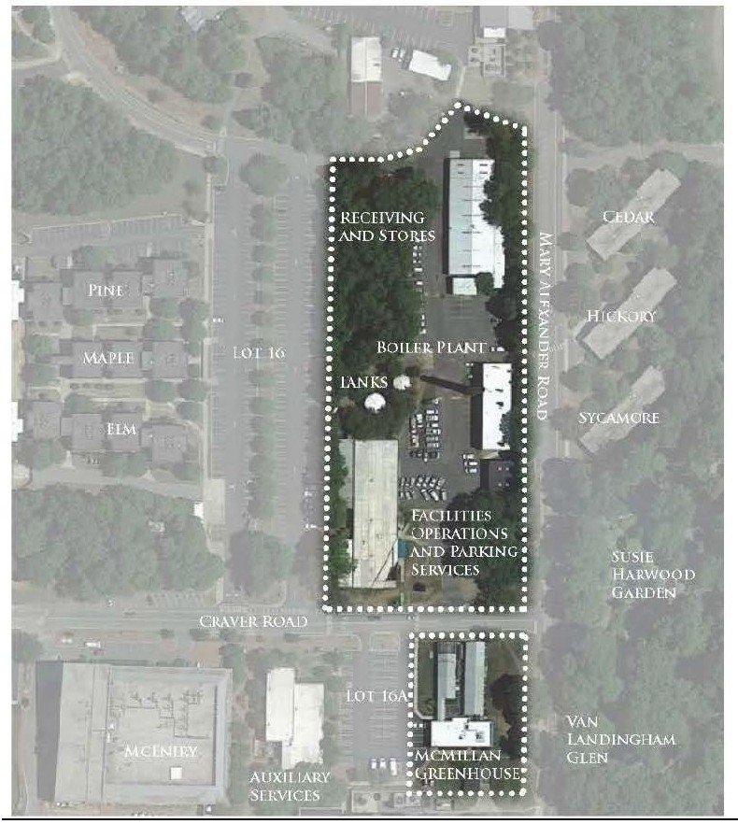

EXHIBIT B

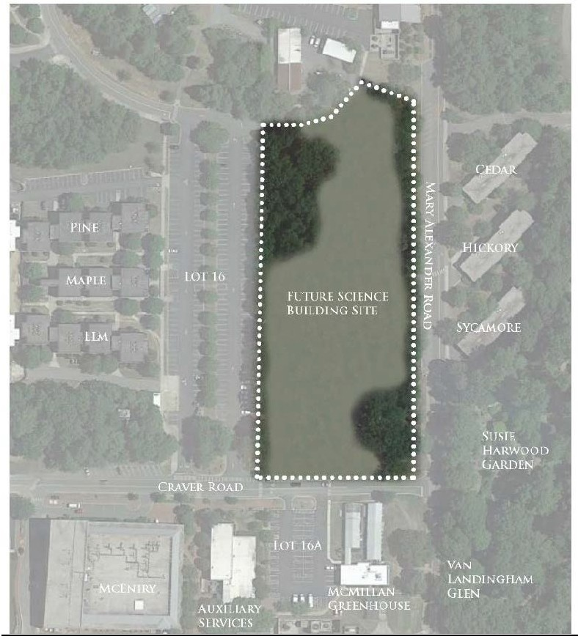[ PROPOSED SOLUTION

