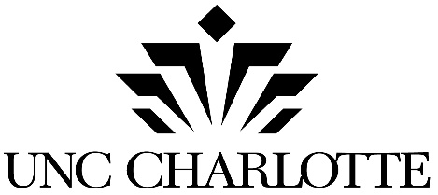

Miltimore Wallis Elevator

CODE 41326 ITEM 307

SINGLE-PRIME CONTRACTOR PRE-QUALIFICATION SUBMITTAL

COMPANY NAME: _________________________________________________________
Pre-qualification submittals from General Contractors for the Miltimore Wallis Elevator project at The University of North Carolina at Charlotte will be accepted no later than 2:00 PM on Tuesday, November 15, 2016.
Applicants are to provide 3 (three) complete copies along with one electronic copy in pdf format (CD, DVD, USB drive, etc.) attached to a print submittal. Please provide a copy of your Safety Manual and HUB Plan as separate digital files.
This submittal form is being provided to all interested contractors who possess a current North
Carolina Contractor’s license.

DIRECT INQUIRIES ABOUT THE PROJECT TO:
Designer: Mr. Scott Shipp
Firm: RDK Engineers
Telephone Number: 704-377-7464
Email: sshipp@RDKEngineers.com

Note: Prequalification for this project will comply with the State of North Carolina Prequalification Policy (attached) in accordance with North Carolina Session Law 2014-42. Please ensure the form is filled out completely and that all requested information is included as prequalification scores will be determined by your initial response to this requirement.

